

open cv tool box

08 /05/ 2019

Univerty of burgundi

Petitjean Théo

Summary

Introduction 1

Goal 1

1 ) Gui and Qt 2

2) How to use the tool box 3

a) Work with an image 3

Logo on our image 4

Add noise to the image 5

Blur the image 6

Display the histogram 6

Histogram equalizes 7

Contour detection using canny 7

Noise reduction 7

Intensity gradient 8

Direction of the contours 8

Hougt line detection 9

Histogram equalizes 10

Harris 11

The shape detector 11

Feature detection sift surf and fast 12

Feature matching 13

Face detection using harr cascade 13

b) Work with a webcam 14

Conclusion 16

# Introduction

## Goal

The main goal of this small paper is to introduce the tool box that I’ve created for the projetct. I’ll explain how to use it and show some result inside the folowing pages.

This code have been created with Qt python and the Qt interface to design the gui, and coded with spider in python. It is requiered to dl opencv to use it.

# 1 ) Gui and Qt

Qt python is a **PyQt** is a [Python](https://en.wikipedia.org/wiki/Python_(programming_language)) [binding](https://en.wikipedia.org/wiki/Language_binding) of the [cross-platform](https://en.wikipedia.org/wiki/Cross-platform) [GUI](https://en.wikipedia.org/wiki/GUI) toolkit [Qt](https://en.wikipedia.org/wiki/Qt_(toolkit)), implemented as a Python [plug-in](https://en.wikipedia.org/wiki/Plug-in_(computing)). PyQt is [free software](https://en.wikipedia.org/wiki/Free_software) developed by the [British](https://en.wikipedia.org/wiki/United_Kingdom) firm Riverbank Computing. It is available under similar terms to Qt versions older than 4.5; this means a variety of licenses including [GNU General Public License](https://en.wikipedia.org/wiki/GNU_General_Public_License) (GPL) and commercial license, but not the [GNU Lesser General Public License](https://en.wikipedia.org/wiki/GNU_Lesser_General_Public_License) (LGPL). PyQt supports [Microsoft Windows](https://en.wikipedia.org/wiki/Microsoft_Windows)

So my Gui have been entirely designed in Qt interface.

# 2) How to use the tool box

## a) Work with an image

Once everything is well installed (OpenCV, and different other library) we are ready to go. The tool box look like the following figure:

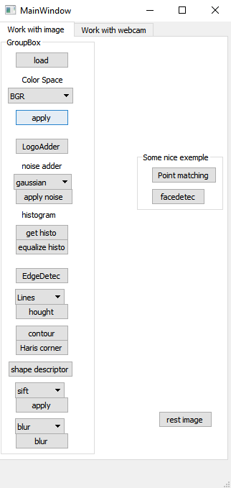

In order to well set the image, we have to follow those steps.

1. First select an image in the folder by clicking on the button load.
2. Be sure, each time you load a new image to apply the color space button bgr atleast once. This button is loading properly the image in the code in order to be sure that each button will work with the good images.
3. Then you can start to play with the different push button of the interface
4. Some Combo box are setted, they contain several parameter and are linked with the button directly under them (often called apply)
5. The button inside the “some nice example” box are to show some nice feature. First is point matching between two images (using sift) The other is face recognition.

### Logo on our image

By clicking on the LogoAdder button you will have to chose a logo in you’r folder. Then a page will open and ask you to draw a Region of interest on the image, draw it then press enter to apply it.

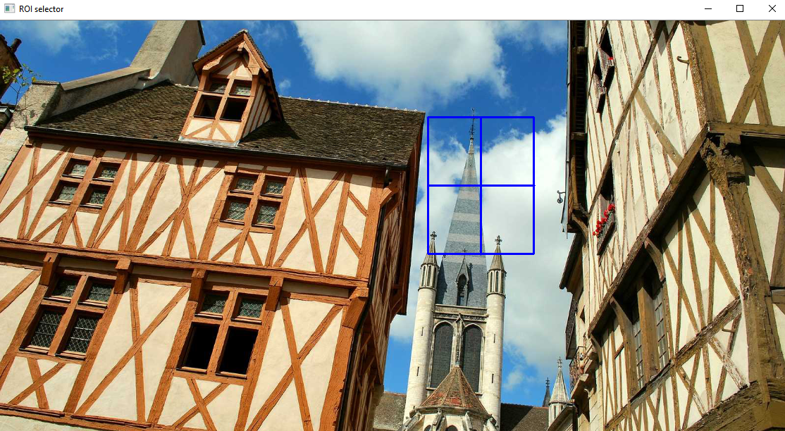

*Figure 1: Roi example.*

After drawing this ROI the logo will be apply to your image.

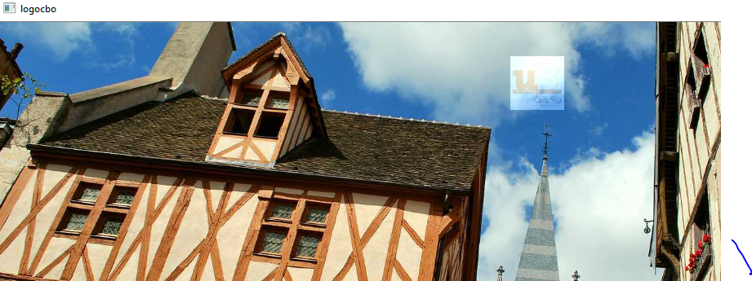

*Figure 2: Printed logo*

### Add noise to the image

One more time, be sure that you apply the brg function at least once to continue using the button. Here you will have the choice between different type of noise to apply them on the image. This function only work on Bgr image,if you wan’t to add the noise in grayscale, did the following order:

1. Load you’r image
2. Apply bgr to it in order to well generate the image in the program
3. Apply a noise in the Bgr image
4. 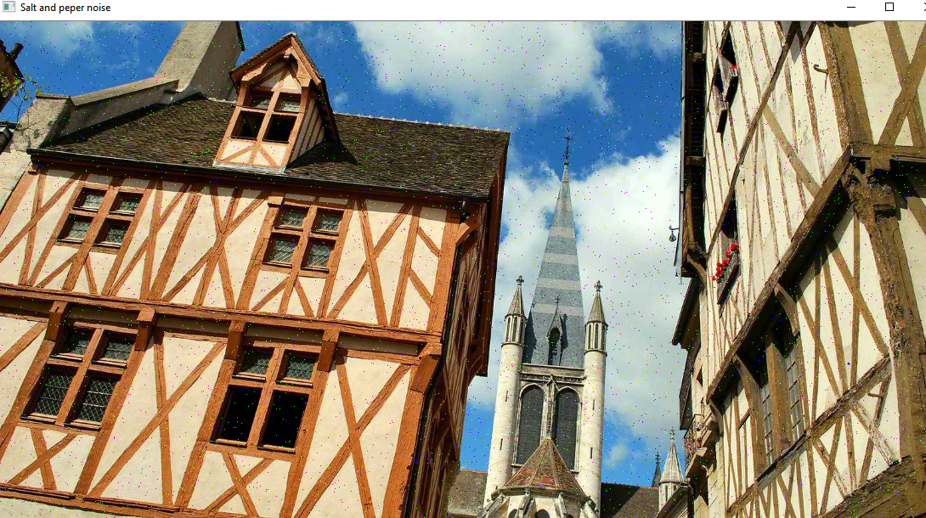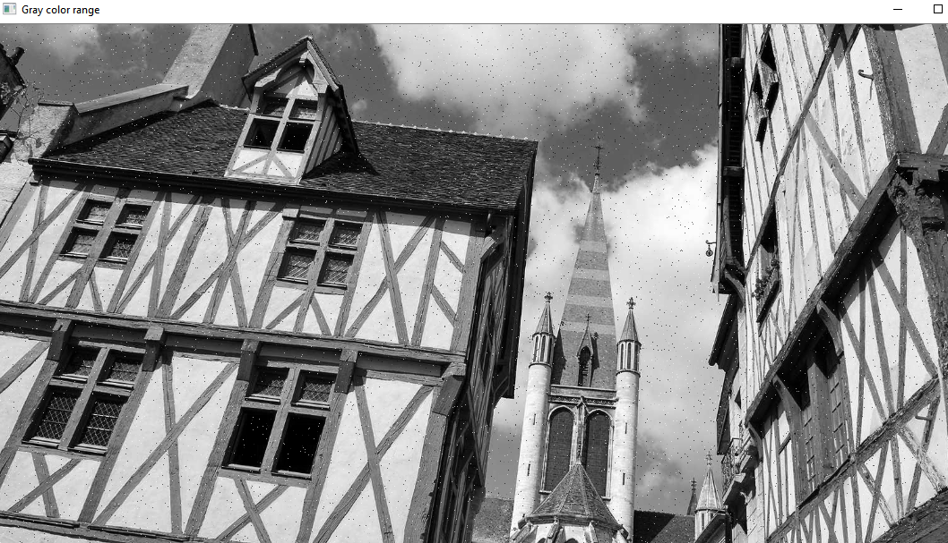Change the Color range of the image (gray or hsv)

*Figure 3: Result of salt and peper noise*

You can also in this box apply the Laplacian and sobel.

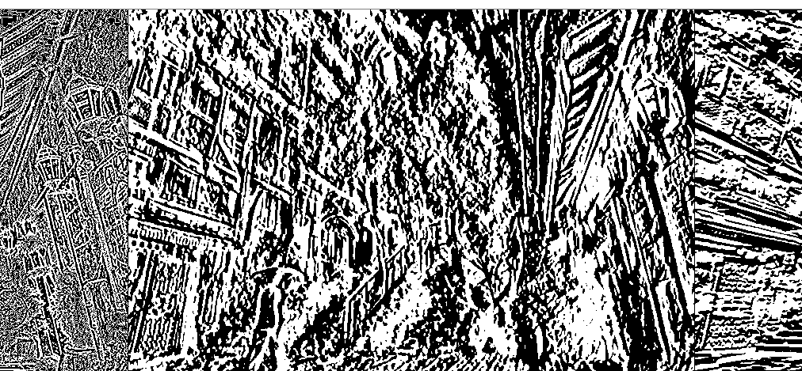

### Blur the image

You have to option for bluring you’r images, gaussian or simple blur, this is an example of the gaussian blur:

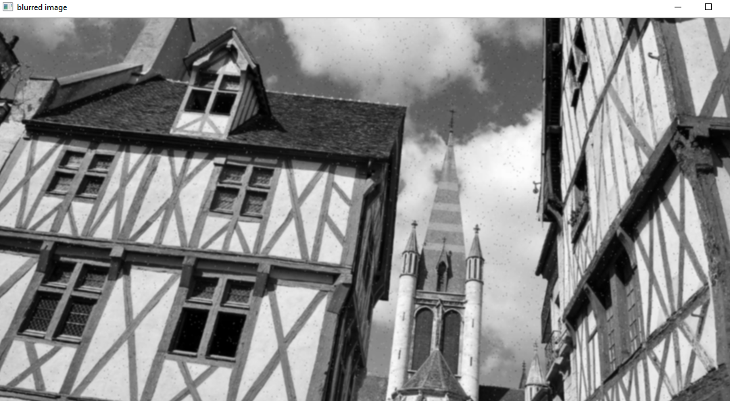

*Figure 4: blured gray salt and peper image*

### Display the histogram

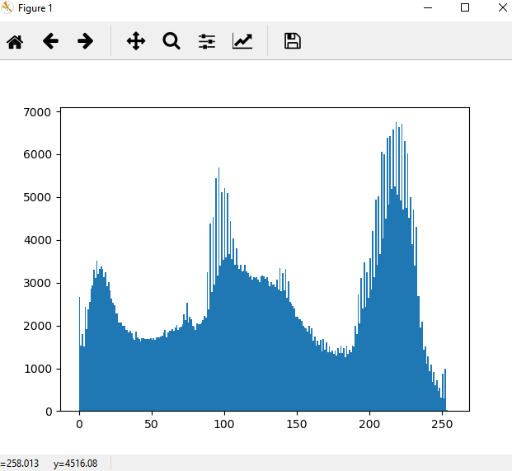It’s possible that the plot show in the command box of python. IN order to avoid this, and have a windows that open whe this button is clicked, we have to change the parameter of spider.

### Histogram equalizes

With this button we will equalize the histogram of the current image, instead of display the histogram we display the image after it’s pixel get equalize (please use a BGR image for this function)

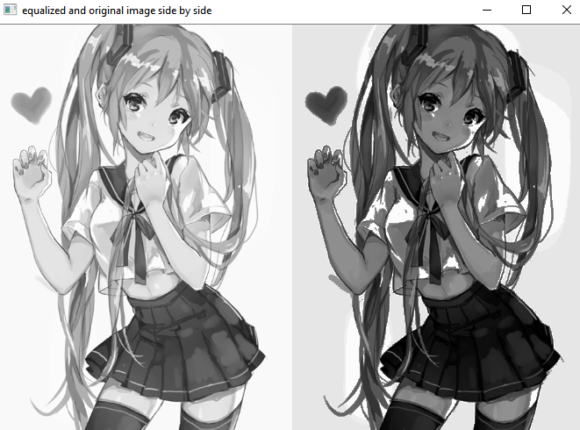

*Figure 6: equalized miku*

### Contour detection using canny

By pressing the button edge detect the program will use the canny edge detection method.

### Noise reduction

The first stage noise reduction is to reduce noise from the original image before detect contours. This allows to remove isolated pixels that could induce strong responses with the computation of the gradient, thus leading to false positives.

A 2D Gaussian filtering is used), which here is the operator of convolution: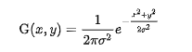

{\displaystyle \mathrm {G} (x,y)={\frac {1}{2\pi \sigma ^{2}}}e^{-{\frac {x^{2}+y^{2}}{2\sigma ^{2}}}}} 5 × 5 discret with σ = 1,4 :

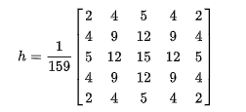{\displaystyle h={\frac {1}{159}}{\begin{bmatrix}2&4&5&4&2\\4&9&12&9&4\\5&12&15&12&5\\4&9&12&9&4\\2&4&5&4&2\end{bmatrix}}}

Usually, a filter is smaller than the filtered image. More the mask is great, less the detector is sensitive to noise and the error of location is growing.

### Intensity gradient

After filtering, the next step is to apply a gradient that returns the intensity of the contours. The operator used to calculate the gradient according to directions X and, is composed of two convolution masks, one of size 3 × 1 and the other 1 × 3:

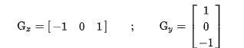

the value of the gradient at a point is approximate by the formula:

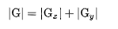

{\displaystyle |\mathrm {G} |=|\mathrm {G} _{x}|+|\mathrm {G} _{y}|} and the exact value is:{\displaystyle |\mathrm {G} |={\sqrt {\mathrm {G} _{x}^{2}+\mathrm {G} _{y}^{2}}}}

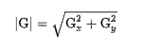

### Direction of the contours

outlines directions are determined by the formula:{\displaystyle \theta =\pm \arctan \left({\frac {\mathrm {G} _{y}}{\mathrm {G} _{x}}}\right)}

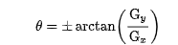

we finally get a map of gradients of intensity at each point of the accompanied image of the directions of the edges

we get the following result :

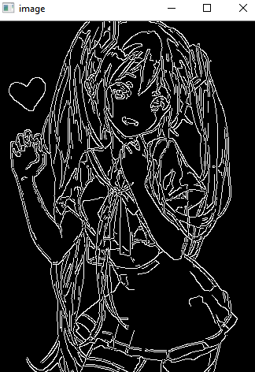

*Figure 7 : canny edge*

### Hougt line detection

This box is proposing to search for circle or line. In the case of the filter be sure that a circle truly exists in the image or it will make the code crash.

The hough line is used here to detect straigt line. To apply this function a edge detection pre-processing is preferable.

See more maths and about the method on the opencv tutorial.

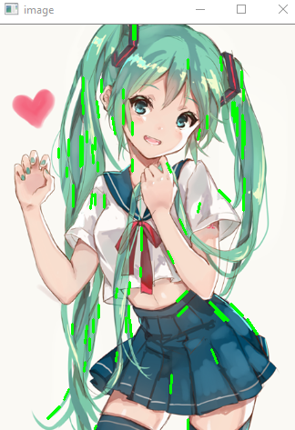

*Figure 8: hought line*

### Histogram equalizes

The draw contour function is inside the button contour, it’s a wildly used function



*Figure 9: draw contour opencv*

### Harris

Haris detector button is using the haris technique in order to determine the intrest point (here printed in red)

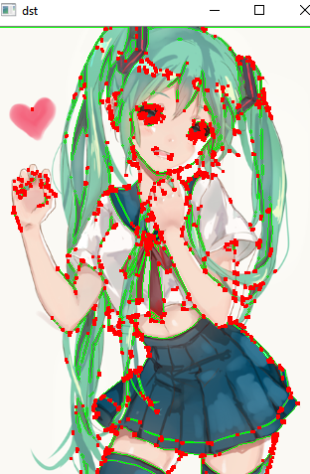

*Figure 10: harris application*

### The shape detector

Here in the same spirit than the logo adder, you will have to select with a roi a shape that you wan’t to crop.

For example let say that you wan’t to crop the “pétanque” ball. In order to do that you have to draw the roi surrounding the ball like shown in the next figure

Then press enter and the ball will be cropped and the background will be removed and replaced by dark pixels.

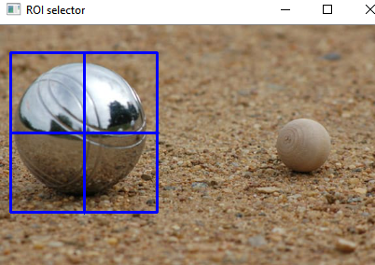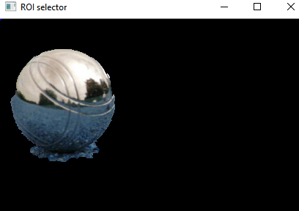

*Figure 11: Croped ball shape*

### Feature detection sift surf and fast

First select the type of feature detection you need then press the apply button ! 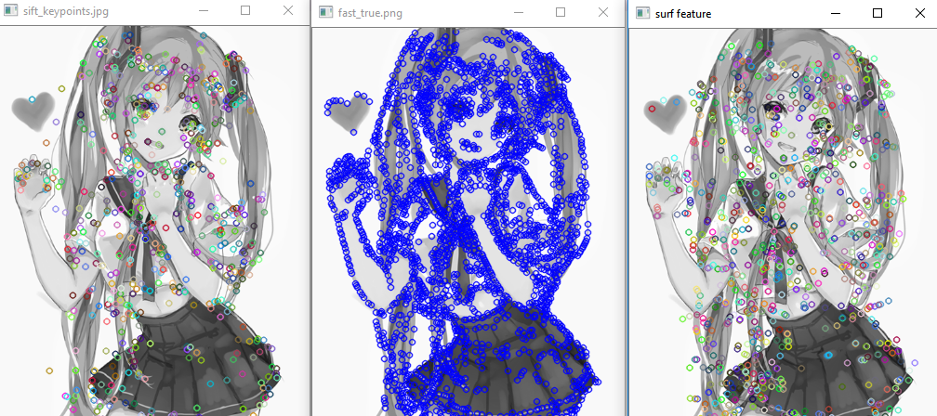

*Figure 12: feature sift,fast,surf*

### Feature matching

The point matching button inside the example box is to illustrate what happen when you make point matching after applying the feature detection we see just before. In this example we have the cover of a harry poter book. The features are exrtracted with sift, then searched in a second image, where I putted the book on the scene. We can see that the book and it’s features are detected.

This can be combined with homography and allow us to detect an object very easily and with a Hight accuracy

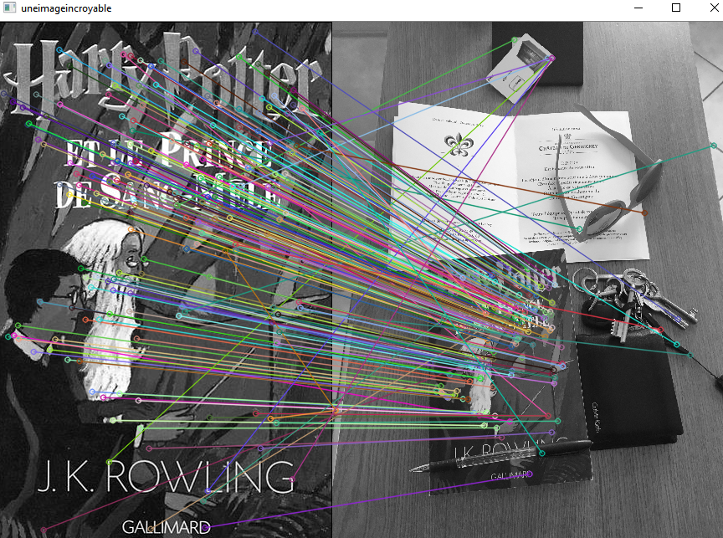

*Figure 13: feature matching*

### Face detection using harr cascade

The other button of the example box is the harr cascade face recognition, if you input an image with face on it, the code will recognize it and draw a region of interest around the faces.

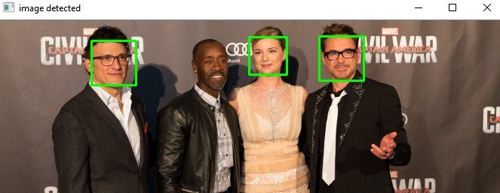

*Figure 14: face detection*

We can see that the face of the black dude isn’t recognize. So I tried several time, with different black man face, and some time it work some time it don’t.

## b) Work with a webcam

For the webcam, the stay relatively the same, the only main difference here is that each and every button is independent, so you will be able to use each on of them just by pressing it. BE sure to leave the opened windows by pressing echap on your keyboard(in order to break the while loop that actually allow us to read the camera frame).

The feature remains the same so feel free to try and play with is.

The two buttons on the extra part are some application that what can be done with open cv, in therm of image analysis.

The first button will allow you to track object based on the colour of this object. It works very well with blue object such as shown in the following figure.

It will detect the biggest contours and draw the contours (with OpenCV draw contour) and define the centre of the biggest detected object

In order to select the colour that you need to track, you will have to play with the track bar and set them properly in order to avoid the most as possible the noise. TO help you doing this, there is 2 windows called mask and result, on wich in can see the result of the mask you are actually setting, once you’r object colour is the only colour range that you can see on the mask, the object will be automatically detected.

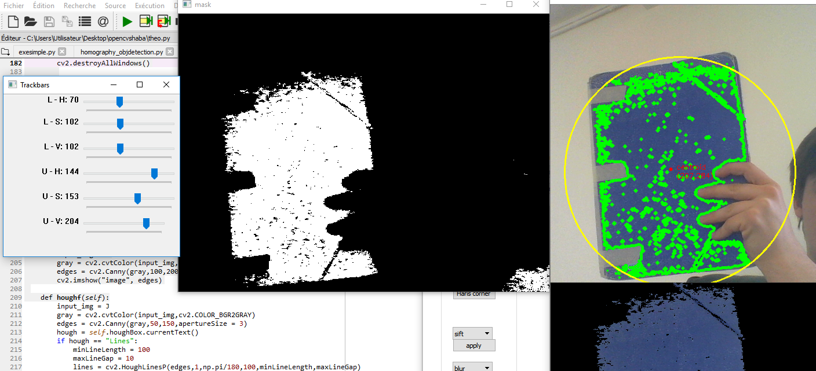

*Figure 15: object tracking based on hsv*

The second button is the application of the harr cascade face detection method on the camera. There is no need of much more explanation.

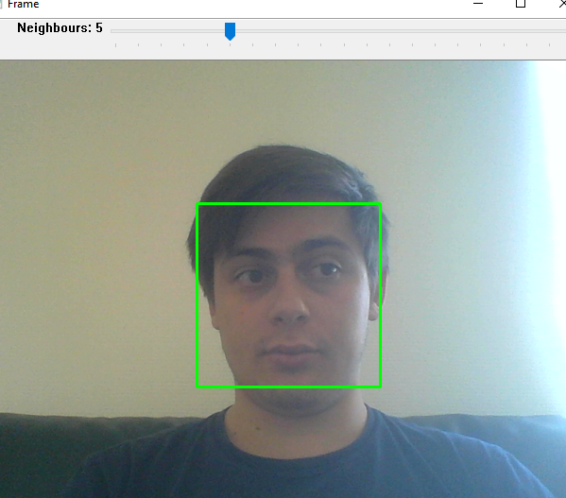

*Figure 16: facedetection*

# Conclusion

To conclude thanks to this project, I saw a lot of open cv tools and method, that allowed me to do object recognition, face detection, hand gesture recognition and so one.

Open cv is, when mastered a really powerful library.